**SQL QUERIES AND OUTPUT**

**1) write a query to create database named ‘sales_analysis’**

**Query :**

#Creating database

CREATE DATABASE sales_analysis;

**Output :**



**2) Write a query to use that database**

**Query :**

#Use Database

USE sales_analysis;

**Output :**



**3) Write query to create table named ‘online_sales’**

**Query :**

#Creating Table

CREATE TABLE online_sales (

order_id INT,

order_date DATE,

product_id INT,

amount DECIMAL(10,2)

);

**Output :**



**4) Write a query to insert atleast 50 records in a table**

**Query :**

#inserting records

INSERT INTO online_sales (order_id, order_date, product_id, amount) VALUES

(1, '2024-01-05', 101, 500.00),

(2, '2024-01-06', 102, 300.00),

(3, '2024-01-07', 103, 450.00),

(4, '2024-01-08', 104, 700.00),

(5, '2024-01-09', 105, 650.00),

(6, '2024-01-10', 106, 200.00),

(7, '2024-01-11', 107, 900.00),

(8, '2024-01-12', 101, 120.00),

(9, '2024-01-13', 102, 350.00),

(10, '2024-01-14', 103, 550.00),

(11, '2024-01-15', 104, 250.00),

(12, '2024-01-16', 105, 450.00),

(13, '2024-01-17', 106, 800.00),

(14, '2024-01-18', 107, 600.00),

(15, '2024-01-19', 101, 1000.00),

(16, '2024-01-20', 102, 300.00),

(17, '2024-01-21', 103, 450.00),

(18, '2024-01-22', 104, 700.00),

(19, '2024-01-23', 105, 600.00),

(20, '2024-01-24', 106, 150.00),

(21, '2024-01-25', 107, 950.00),

(22, '2024-01-26', 101, 500.00),

(23, '2024-01-27', 102, 400.00),

(24, '2024-01-28', 103, 800.00),

(25, '2024-01-29', 104, 700.00),

(26, '2024-01-30', 105, 550.00),

(27, '2024-01-31', 106, 300.00),

(28, '2024-02-01', 107, 450.00),

(29, '2024-02-02', 101, 600.00),

(30, '2024-02-03', 102, 500.00),

(31, '2024-02-04', 103, 700.00),

(32, '2024-02-05', 104, 800.00),

(33, '2024-02-06', 105, 600.00),

(34, '2024-02-07', 106, 350.00),

(35, '2024-02-08', 107, 120.00),

(36, '2024-02-09', 101, 900.00),

(37, '2024-02-10', 102, 250.00),

(38, '2024-02-11', 103, 650.00),

(39, '2024-02-12', 104, 550.00),

(40, '2024-02-13', 105, 750.00),

(41, '2024-02-14', 106, 300.00),

(42, '2024-02-15', 107, 800.00),

(43, '2024-02-16', 101, 400.00),

(44, '2024-02-17', 102, 150.00),

(45, '2024-02-18', 103, 500.00),

(46, '2024-02-19', 104, 600.00),

(47, '2024-02-20', 105, 300.00),

(48, '2024-02-21', 106, 450.00),

(49, '2024-02-22', 107, 550.00),

(50, '2024-02-23', 101, 700.00);

**Output :**



**5) Write a query to view all records from the table**

**Query :**

#View all records

SELECT * FROM online_sales;

**Output :**

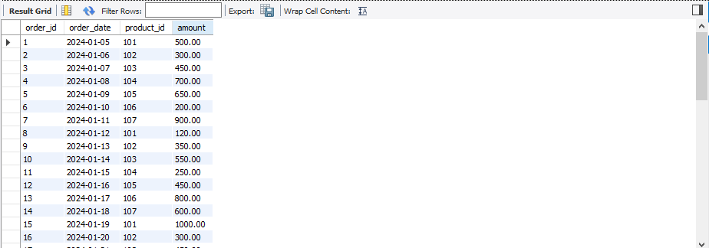

**6) Show total revenue for each month.**

**Query :**

SELECT MONTH(order_date) AS month, SUM(amount) AS total_revenue

FROM online_sales

GROUP BY MONTH(order_date);

**Output :**

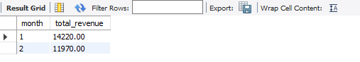

**7) Count the number of distinct orders each month.**

**Query :**

SELECT MONTH(order_date) AS month, COUNT(DISTINCT order_id) AS total_orders

FROM online_sales

GROUP BY MONTH(order_date);

**Output :**

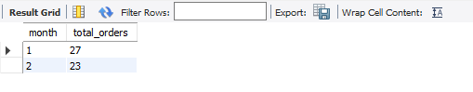

**8) Calculate total revenue for each year.**

**Query :**

SELECT YEAR(order_date) AS year, SUM(amount) AS total_revenue

FROM online_sales

GROUP BY YEAR(order_date);

**Output :**

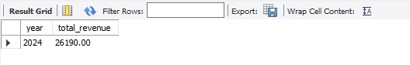

**9) Show total revenue for each product.**

**Query :**

SELECT product_id, SUM(amount) AS total_revenue

FROM online_sales

GROUP BY product_id;

**Output :**

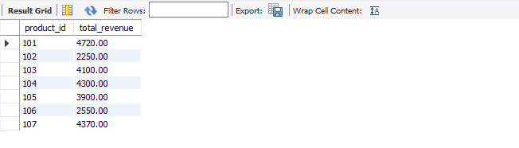

**10) Count total orders per product.**

**Query :**

SELECT product_id, COUNT(order_id) AS total_orders

FROM online_sales

GROUP BY product_id;

**Output :**

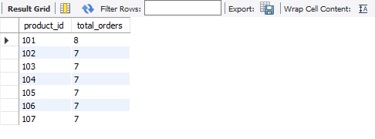

**11) Find the month with the highest number of orders.**

**Query :**

SELECT MONTH(order_date) AS month, COUNT(DISTINCT order_id) AS total_orders

FROM online_sales

GROUP BY MONTH(order_date)

ORDER BY total_orders DESC

LIMIT 1;

**Output :**

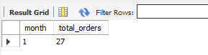

**12) Find the month with the lowest revenue.**

**Query :**

SELECT MONTH(order_date) AS month, SUM(amount) AS total_revenue

FROM online_sales

GROUP BY MONTH(order_date)

ORDER BY total_revenue ASC

LIMIT 1;

**Output :**

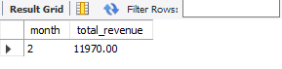

**13) Display monthly revenue sorted from highest to lowest.**

**Query :**

SELECT MONTH(order_date) AS month, SUM(amount) AS total_revenue

FROM online_sales

GROUP BY MONTH(order_date)

ORDER BY total_revenue DESC;

**Output :**

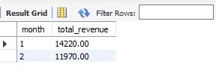

**14) Display monthly order volume (count of distinct orders).**

**Query :**

SELECT MONTH(order_date) AS month, COUNT(DISTINCT order_id) AS order_volume

FROM online_sales

GROUP BY MONTH(order_date);

**Output :**

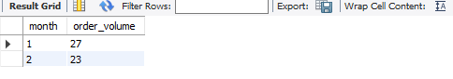

**15) Get total revenue per product for January.**

**Query :**

SELECT product_id, SUM(amount) AS revenue

FROM online_sales

WHERE MONTH(order_date) = 1

GROUP BY product_id;

**Output :**

